Exercise 2 - Managing Stakeholders

Stakeholders are people, groups and organisations that have a vested interest in the operational plan and its outcomes. Each stakeholder will have different needs and wants. It’s an important role of the manager to identify and manage these expectations so that operational plans progress as planned.

Considering your own department, use Eden and Ackermann’s stakeholder model to identify different stakeholders who will have a vested interest in your operational plan and identify strategies to manage them effectively.

Part 1:

First of all, make a list of different stakeholders who will have an interest or ‘stake’ in your operational plans - aim to identify at least ten. When making the list, consider people from within your organisation (internal stakeholders) as well as those from outside (external stakeholders). Now plot each of the stakeholders identified onto the Eden and Ackermann ‘Power vs Interest’ Grid below:
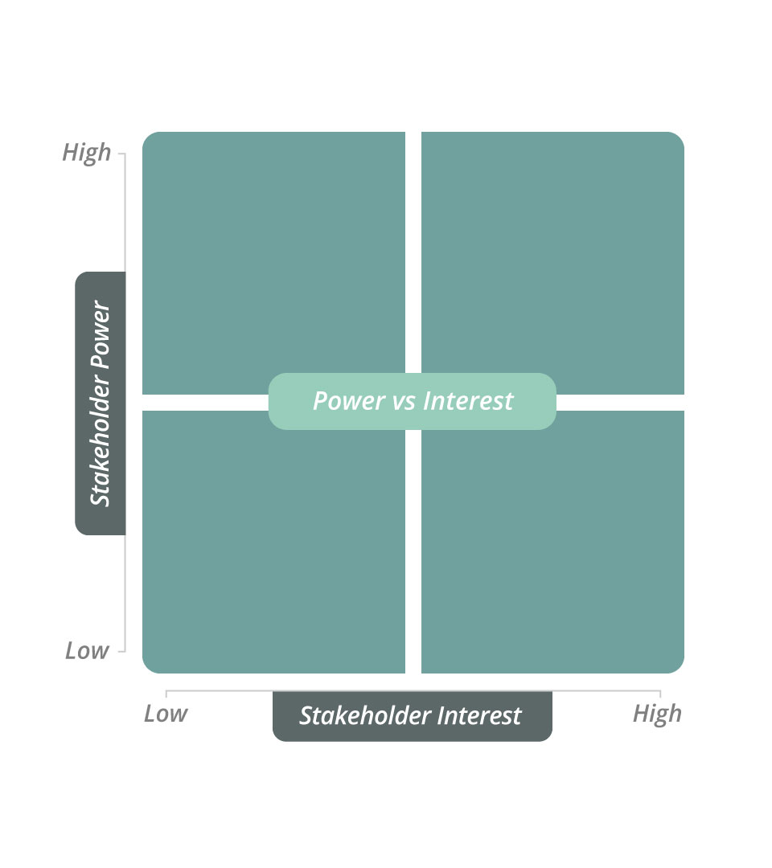

Power vs Interest
Stakeholder Power | High
 | Low
 |  | Low | High
 |  | Stakeholder Interest

Part 2:

Now that you have identified the power and interest each stakeholder has in your operational plans, consider the best way to manage their different needs and wants.

Select one stakeholder from each quadrant, and identify the specific strategy you will adopt (i.e. manage closely, keep informed, keep satisfied or monitor) and the specific actions you will take to manage each relationship effectively.

Stakeholder | Strategy | Specific Actions to Manage Needs and Wants

